|  |
| --- |
| Report Name |

|  |
| --- |
| Project Name  Email: [Email Here]  Website: [Website Here] |

|  |  |
| --- | --- |
| Name, Job Title  Email [Email Here] | logo-placeholder |

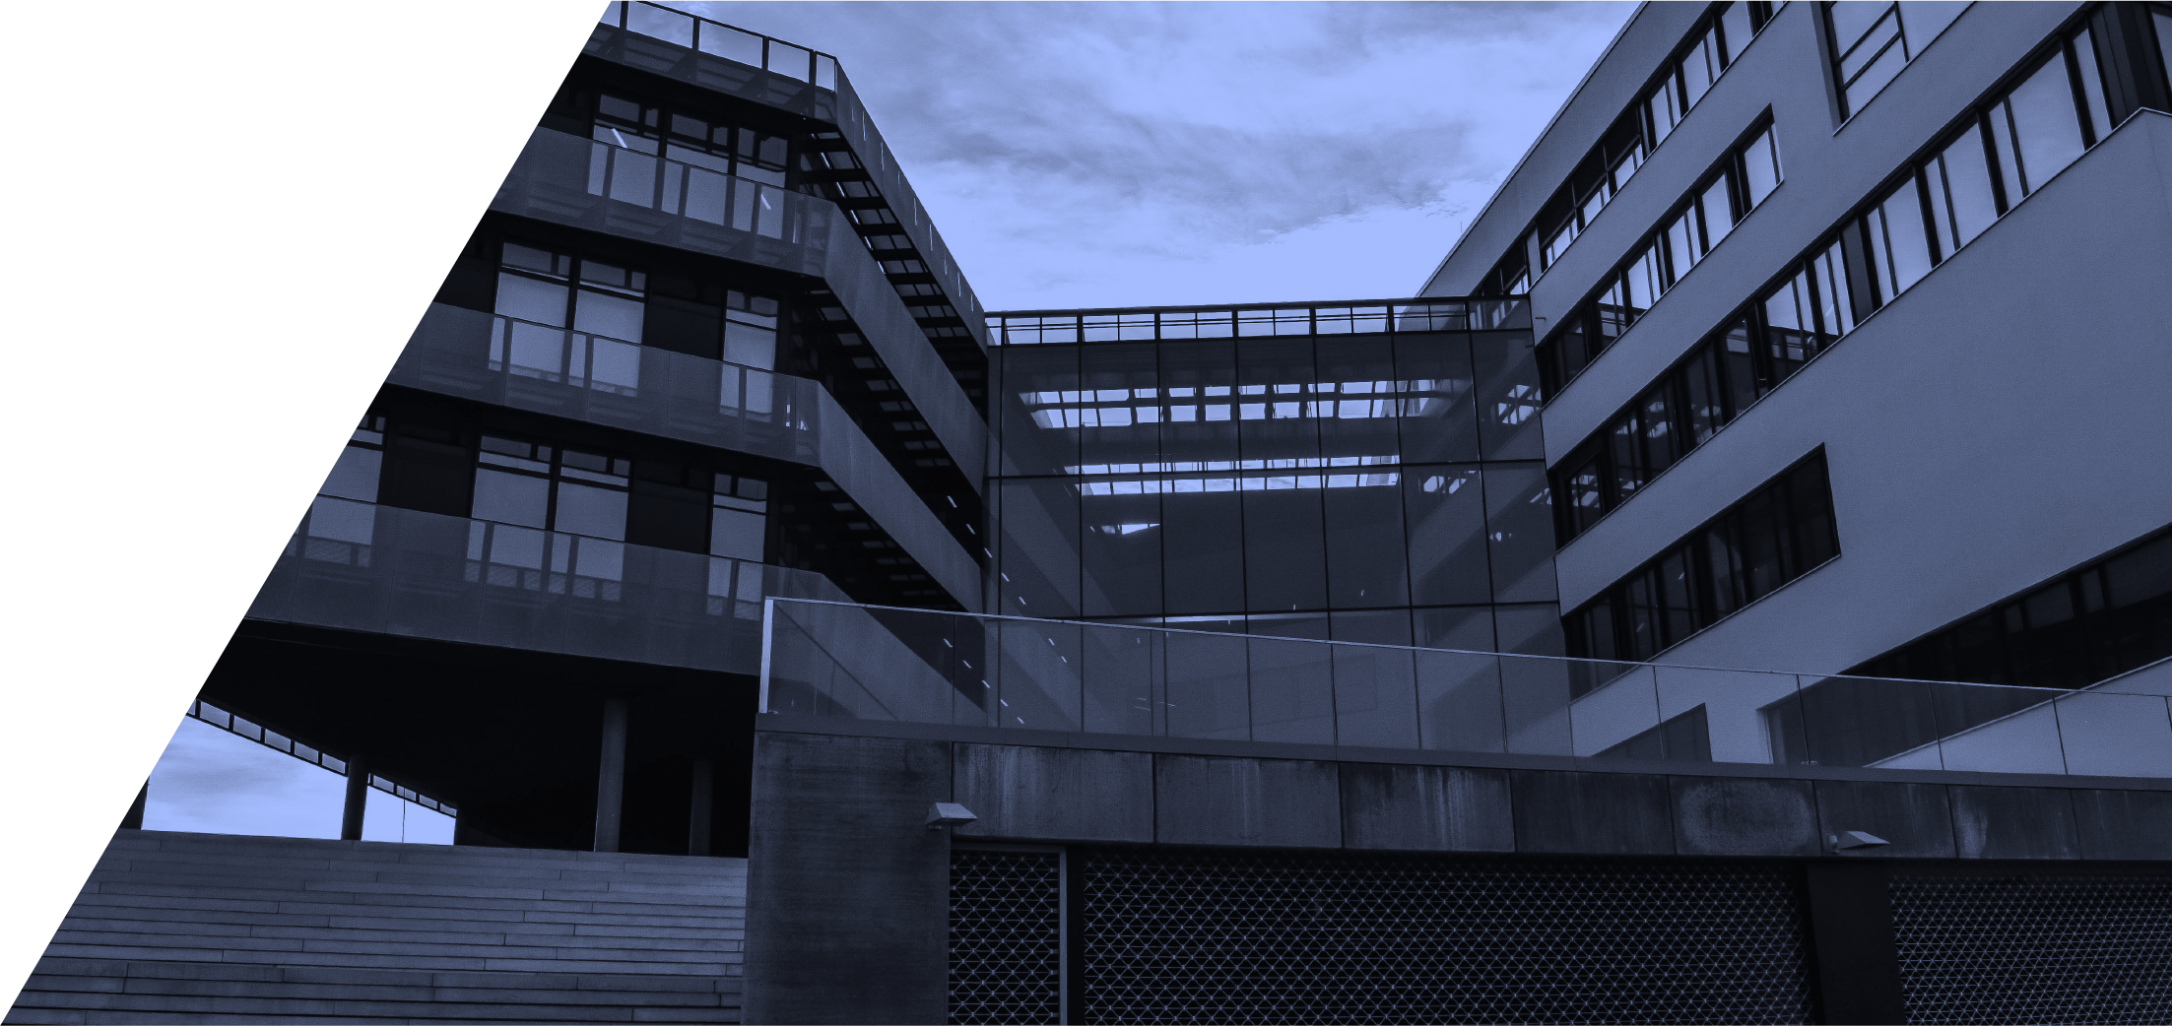

Contents

Executive Summary 3

Introduction 3

Describe your scenario 4

Target audience 4

Report outcomes 4

Recommendations 7

Conclusion 9

Summary 9

|  |  |
| --- | --- |
| Assessment Report - Submission details | |
| Participant Name: | Jack McLovin |
| Topic: | [Enter topic here] |
| Unit Code & Name: | [UNIT CODE] – [Unit title]Module 3 Project Task 2.8 |
| Trainer/Assessor Name: | Yaser Farag |
| Submission date: | ***____ / ____ / ____5/10/2023*** |
| Work submitted:   * Report of all the documents required to assess the materials * Short-form summary of safety concerns when working with materials | |
| Declaration: | In submitting this work I declare that no part of any assessment I submit has been copied from another person’s work, except where clearly noted on documents or work submitted. I declare that no part of any assessment I submit will have been written for me by another person. I understand that plagiarism is a serious offence that may lead to disciplinary action. |
| Participant Signature:  (Insert Name) | Jack McLovin |

|  |
| --- |
| Executive Summary *The purpose of this document is to provide a management framework to ensure that levels of risk and uncertainty are properly managed for the remainder of the project. As risk management is an ongoing process over the life of a project, the Risk Register must be considered a ‘snap shot’ of relevant risks at one point in time.* |
| Introduction |

## Describe your scenario

## Target audience

## Report outcomes

Common preservatives used within the Australian environment

Copper Chrome Arsenate, Creosote, Alkaline Copper Quaternary, Boron.

Galvanisation, paint and coatings, corrosion inhibitors, cathodic protection

Concrete, plastic and polymers

How these treatments can be applied to increase the durability of timber

CCA – wood preservative against decay fungi, insects, and marine borers.

Creosote – decay, insects, and fungi

ACQ – similar to creosote but not as dangerous

Boron – least toxic.

How these treatments can be applied to increase the durability of ferrous metals used in construction

Prevents corrosion by sacrificing or coating.

How these treatments can be applied to increase the durability of ferrous and non-ferrous metals used in construction

Stops corrosion and rust while building strength in the metal.

Which Australian Standard must these treatments adhere to

### Timber Treatment Standards:

1. **AS 1604 - Timber Preservatives:**
   * This standard provides requirements for the selection and application of preservatives for timber and wood-based products.
2. **AS 1609 - Methods for Preservative Treatment of Timber:**
   * It outlines the methods and procedures for treating timber with preservatives.
3. **AS 4604 - Timber - Natural durability ratings:**
   * This standard provides a system for assigning natural durability ratings to different timber species.

### Steel Protection Standards:

1. **AS/NZS 4680 - Hot-dip galvanized (zinc) coatings on fabricated ferrous articles:**
   * This standard specifies the requirements for the hot-dip galvanizing of steel articles to provide corrosion protection.
2. **AS 4312 - Methods of testing coated ferrous products:**
   * It outlines methods for testing coatings, including those used for corrosion protection on ferrous products.
3. **AS/NZS 2699.3 - Built-in components for masonry construction - Lintels and shelf angles (durability requirements):**
   * While not specific to steel, this standard outlines durability requirements for certain built-in components used in construction.

### General Building Standards:

1. **AS/NZS 2311 - Guide to the painting of buildings:**
   * This standard provides guidance on the selection and application of paints and coatings for various surfaces, including steel.
2. **AS 3600 - Concrete structures:**
   * For concrete materials, this standard provides requirements for the design and construction of concrete structures.

What safety precautions (if any) must be taken when handling and working with timber

That the gas to sterilize it doesn’t get into your lungs.

Treated timber can be considered hazardous waste.

Gloves to prevent splinters, eye protection and ear muffs when cutting with machinery. Measure twice cut once. Hold the nail gun head away from flesh.

Ensure there’s wood to brace the wood to brace the wood (top and bottom held together with verticals distant by size of insulation with wood between the verticals). Nails go down, so the force of gravity holds it together.

What safety precautions (if any) must be taken when handling and working with ferrous metals

That the rust doesn’t get into your skin

And that it doesn’t spread and consume the metal

It’s very dense so be careful of the size, often needs machinery to move around like cranes over a certain length (anchor at center of gravity (moments of inertia)). Ensure welds are of a consistent rating that adequately covers the seem between two pieces of metal. Thicker gloves when welding or cutting. Angle grinders and cutting needs proper eye protection for the sparks, and not just glasses as the sparks can fly behind them, full face welders mask. Overalls when cutting and welding to cover all exposed skin in thick heat protective non-flammable material. Conducts electricity so no exposed wires

What safety precautions (if any) must be taken when handling and working with non-ferrous metals

That it doesn’t deteriorate (perhaps requires repeat coating) and what way it needs to be cleaned (perhaps requires particular chemicals). Can conduct electricity so no exposed wires. Often less need to prevent rust, for example zinc and aluminium.

## Recommendations

## Conclusion

In Conclusion materials deteriorate and they come with specification on how they should be treated in regards to the chemicals used to fix this issue.

## Summary

General overview of the report.

Dot point this section of all the areas covered examples may include

Timber

Iron based metals

Non iron based materials